**Problem background**

1. **Problem introduction**

For animal lovers, going to pet cafe has become a popular and daily activity, However, in real life, it’s time-consuming and energy-draining as there is no platform dedicated to providing information related to pets and pet cafes, which is interspersed among multiple platforms where there isn’t a systematic introduction and clear classification. Morever, there is a lack of a community platform specifically for them to share things about pet cafes and pets.

Therefore, I would like to create a website dedicated to providing pet and pet cafe information for pet lovers in Weihai. As a smaller third-tier city, Weihai lacks a platform that contains and updates this kind of information in a timely manner, and because the city is small, the number of stores is small and relatively close together, and people are more connected than those in larger cities, it is easier to build a community and community concept. The main purpose of this website is to help pet lovers in Weihai or traveling to Weihai to better plan and improve the whole experience of going to a pet cafe from online to offline.

1. **Persona type**

People who love pets and have the habit of going to pet cafes frequently and sharing related experience.

1. **Problem statement**

How might we make a pet lover and regular at pet cafes (who) address the problem of finding some good or new pet coffee shops efficiently and have a place to find or discuss information and experiences related to pets (what) to achieve the goal of becoming more proficient at playing with pets and improve their experience at pet cafes?

**Requirements**

1. **User journey map**

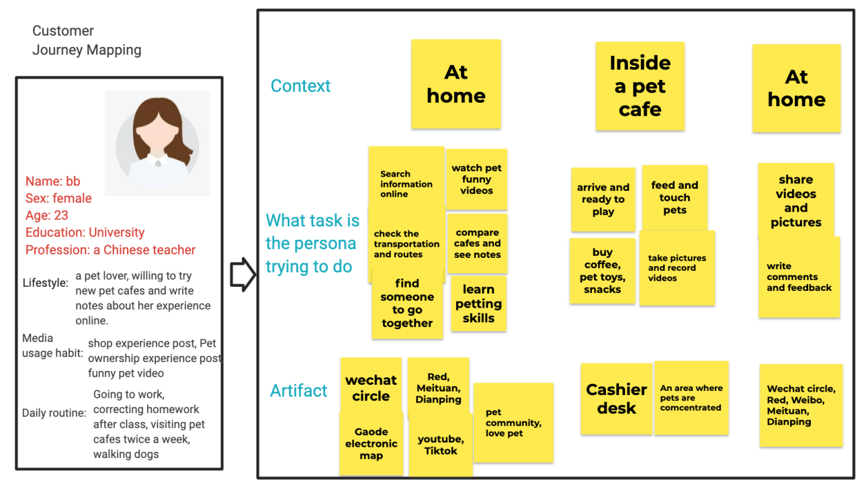

**<https://jamboard.google.com/d/19FopdVepDw4ibbePjQcTZqeEi8Csulle8ce1-IIM3HM/viewer?f=0>**

1. **Function and content requirements**

Before going:

* Decide whether to go or not: get recommendations from friends or social platforms.
* Decide who to go with: check others’ wishes and time; Invite friends or partners online to go with.
* Decide where to go: search information about pet cafes online, see recent comments; check details such as prices, varieties of pets, the decoration of cafe and compare different options.
* Decide when to go: check schedule of your friends and you; check the opening time of cafes.
* Decide how to go: plan best traffic routes on electronic map
* Others plan: make reservations and buy vouchers online; learn petting skills or considerations; estimate expenses in advance; check the weather; buy some pets’ snacks or toys

In the pet cafe:

* Show coupons code
* Check menu and make orders
* Play with pets
* Take photos and record videos of pets

After going back home:

* Upload videos and photts
* Suggest and write reviews to the store
* Writing Experience Posts
* Watch funny pet videos to relax

1. **Positioning map**

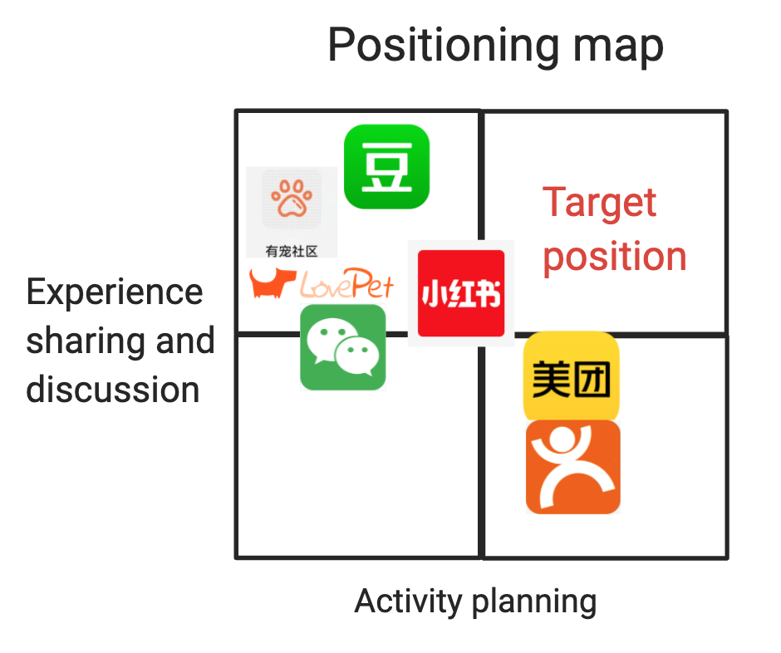

**<https://jamboard.google.com/d/19FopdVepDw4ibbePjQcTZqeEi8Csulle8ce1-IIM3HM/viewer?f=2>**

**Design**

**The site map**

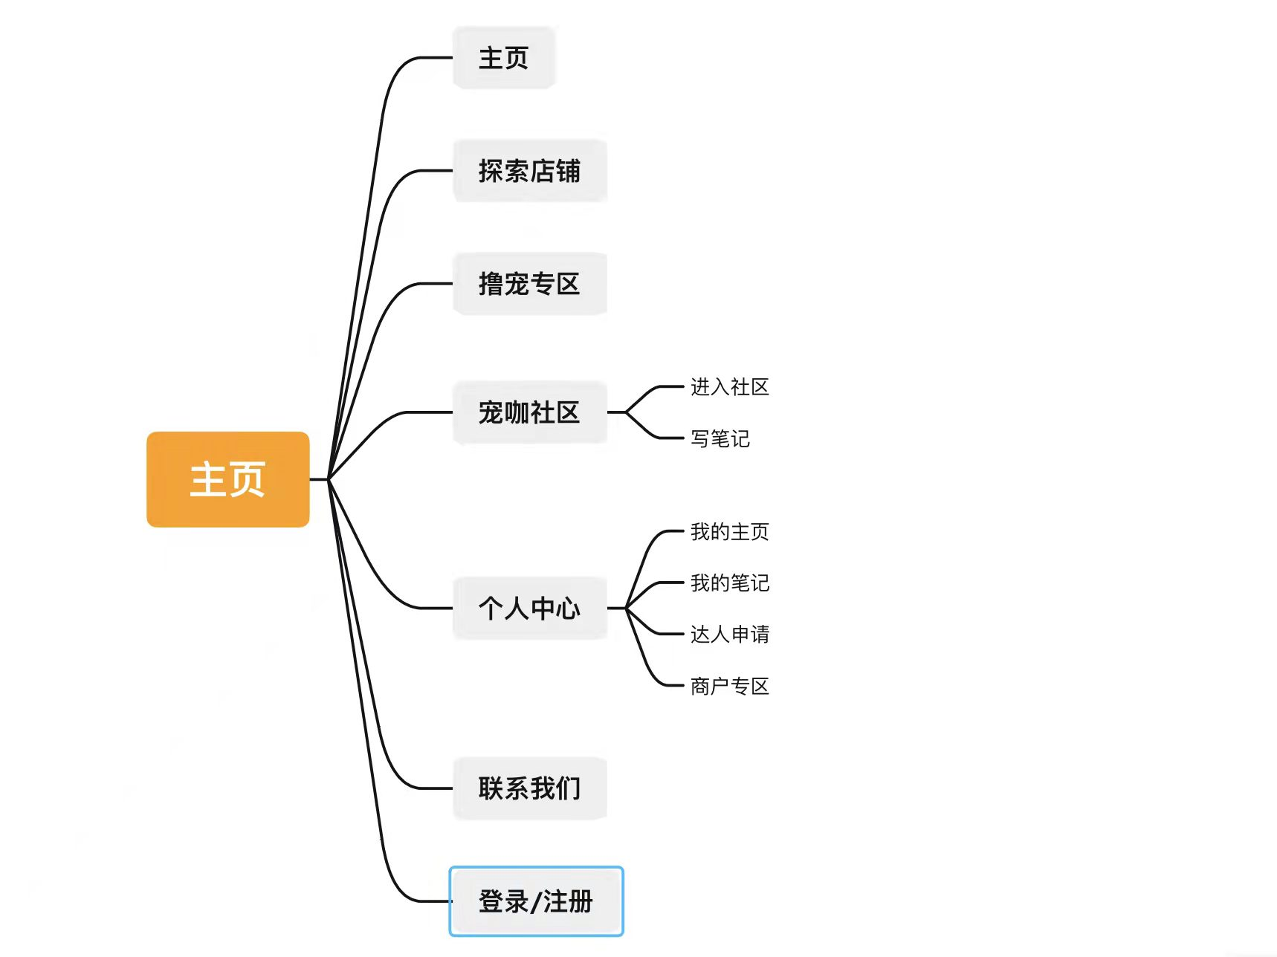

**探索店铺：**Firstly, the search process is not convenient, and consumers need to combine multiple platforms such as Meituan, Dianping and Red to select stores, and these platforms do not set pet cafes as one of the categories. The second problem is that the search results are not accurate, as many businesses do not contain the word "pet cafe" in their store names, making it difficult for users to search for them. Based on this, for the first two problems, the “探索店铺” page displays information about cats, dogs and general pet cafes, so users don't have to worry about missing certain stores.

**撸宠专区：**This page displays some videos and articles about petting skills and related issues. On the one hand, users can learn some skills about petting, taking photos for pets or safety issues in advance while browsing this page, enhancing the experience and safety of playing with pets when they arrive at the store. On the other hand, users’ work can appear on this page after they click the button to apply for being an expert, which could help vloggers or people with sharing habits to get more attention and traffic. For merchants, applying to become a “quality merchant” can also help gain more attention in the community and bring more traffic to their own stores.

**宠咖社区：**Another problem is that there is a lack of a community platform specifically for sharing things about pet cafes and daily life of pets. For this problem, the community provides a platform for users to share. Merchants can show more information related to their stores, such as new store openings, the latest store news, whether they offer pet boarding and details of pet names and characteristics, so that users can learn more information and details, making it easier for them to choose. Merchants can learn more about consumers' demands through users' notes, and have more two-way direct interaction with users rather than just accepting one-sided comments from them, so as to better operate their stores.

**个人中心：**Users can post notes in the community and edit after posting. Active users in the early stages of the site can apply for being an expert in “达人申请” and get some rights and benefits, such as pet cafe coupons, weekly prize draws, and official rewards for note exposure, and the most important is that they could get access to submit articles or videos to the site in “宠咖社区”. For shop owners, after the stores submit their business licenses and other information, and the store information is verified, their stores can be successfully enrolled in the "Explore Store". In addition, they can not only apply to become a "quality merchant", but also choose to cooperate with us in various ways such as providing coupons, raffle prizes, banner ads, etc.

**登录/注册：**users can post notes and participate in community interaction only after registering and logging in, and the same goes for stores. Otherwise they could only seen the basic information about shops and others’ notes and works.

**Test/evaluation**

1. **Usability analysis**
2. The homepage is a bit vague, and the interviewees cannot clearly see that this is a website that provides information about pet cafes, and some may think it is a cat restaurant. So next I will add more directional text on the homepage.
3. Participants said that in ‘宠咖社区’ sector, there is an overlap between the ‘owners’ and ‘customers’ groups, and the product coverage is too wide, which makes the app's positioning unclear. At first, I thought I will remove the part of ‘owners’, and only keep the owner and customers. But then I found that there is no need to categorize consumer and shop owners apart, but rather to make the community a whole. Just add a search box and users can enter keywords to find information according to their needs. Customers can share the experience of visiting pet cafes as well as things related to pets, while shop owners could provide more details about their shops.
4. UI design needs to be improved. Respondents reported that they were unable to know which sector they were in during use, and lacked corresponding prompts. Subsequent improvements will thicken the color of the section where the user is located.
5. The location for posting notes is not clear enough. During the operation of the web version, the first reaction of the interviewees was to open ‘forest community’ and post in the community, instead of directly clicking the icon in the upper right corner of the web page. Therefore, the function of publishing notes will be added “宠咖社区” in the future.
6. The user expressed the hope that there will be a partition in each item in the community so that the corresponding content can be retrieved quickly. So in the future, I will add search functions in the community.
7. On the page of “探索店铺”, the category name of the pet cafe confuses the interviewees and some of them does not know the true meaning of this category. Firstly, I think the name of each category will be written more directly. But as the number of pet cafes in Weihai is quite small, so I decided to cancel the classification of dog cafe and cat cafe.
8. The example words in the boxes on the login and registration pages are not clear enough, and the interviewee does not know the meaning of the second step of registration. Therefore, a more direct guide example will be filled in the box later.
9. Regarding its bussiness value, the site will cooperate with some famous vloggers or KOLs or local shop owners , displaying their works on “撸宠专区”, which can improve the exposure and popularity of their work, and also attract other users to apply to contribute to the site. At the same time, businesses can cooperate with the active reviewew in the community to promote their stores, or contact us to invest in advertising on the site. As in the interview, participants mentioned that their expectation is that being an expert can bring them traffic and attract cafes or relative shops to cooperate with them and invest in them. After the site accumulating some traffic, shop owners may contact the site for getting more traffic by cooperating with us.
10. **A/B test results**

The variable ab test is the name of the home button. From the results, it seems that the variant has more sessions, more page views, longer view time, and more average views per session, indicating that the name of the home button "click here" is more direct and more attractive to users than "explore more". So I keep the variable and change the name to "click here".

1. **Recommendations**

The next step will be to conduct interviews and surveys mainly for three groups of people. One is the owners of Weihai Pet Café, interviewing them whether they are willing to be on the site, what information and data they want to get, and under what circumstances they are willing to invest in cooperation. The second is some video professionals and local KOLs, asking them about their willingness to cooperate and how much traffic they expect the site to bring to their works. The third was pet lovers, the target audience for this site. We will put the website into relevant groups on platforms like Douban for users to participate in testing the website and give their demands and opinions.

**Appendix**

1. **Figma prototypes**

**<https://www.figma.com/file/1XwspOYngjLSczYgi9At5k/prototype-%E9%87%87%E8%AE%BF%E4%BF%AE%E6%94%B9%E5%90%8E?node-id=0%3A1>**

1. **3rd party Bootstrap templates used**

**<https://startbootstrap.com/theme/business-casual>**

1. **Admin acount**

User name: Toris

Password:111111

1. **Usability interview questions**

* Plese register and log in first.
* Looking at the design of the homepage, what do you think this site does? What can be done in this webstie?
* How do you find a pet cafe you want to go to?
* How do you post a note? Post it and where will you find this note once it's posted?
* Is this interface clear? Is the existing function necessary and what functions should be added?
* What are your overall impressions and feelings about the Pet Cafe Community interface? What do you think you can do on this page? Try it. Is there anything unclear?
* Is this interface clear? Is the existing function necessary and what functions should be added?
* What do you think of official titles like "quality merchant" and "expert"? If you are willing, how do you apply for it?
* Overall, do you find this task difficult? （esay--difficult）
* Please rate this website (1-5).

1. **Data scraped**

Data scraped from 3rd party websites used is mainly from Meituan and Dianping, which is included in the database.db file.

Meituan: <https://weihai.meituan.com/s/%E7%8C%AB%E5%92%96/>

Dianping: <https://www.dianping.com/search/keyword/152/0_%E7%8C%AB%E5%92%96>